Yr 9 Algebra Revision ANSWERS
1.
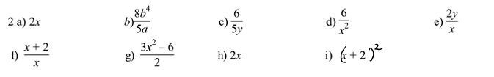
2.
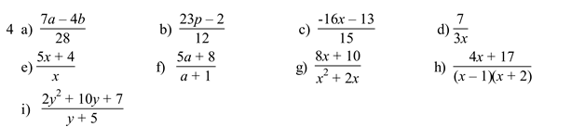
3.
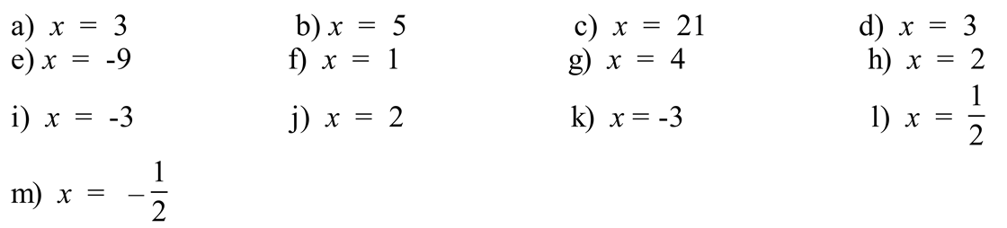

4.
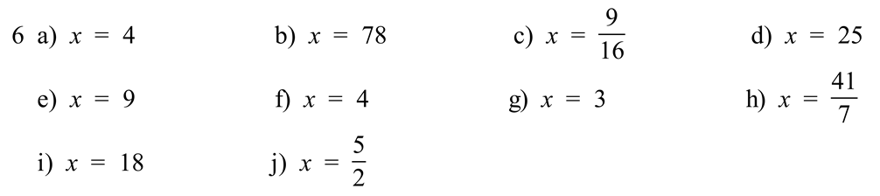
5.
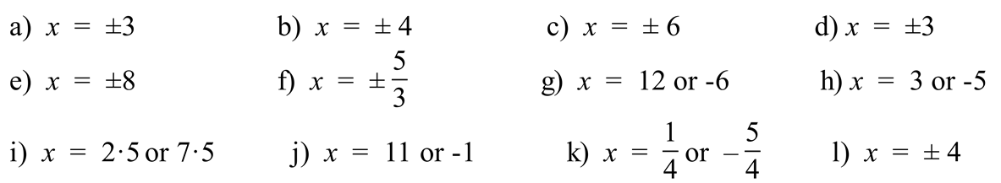

6.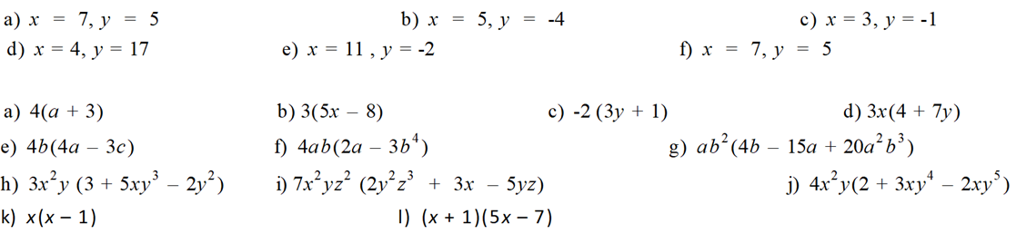
7.


8.

